Shausu Seember Naomi - 20087097,
Luis Alberto Castaneda Avila - 20062651
By

Technical Report for Data Storage Solutions for Data Analytics
Contents
1. Introduction 2
1.2. Reasons for selecting the subject area AND DATA 2
1.3. Vision and Goals 2
1.4. Key StakeHolders 3
1.5. Business requirements 3
2. SCHEMA 4
2.1 FacT TABLE 4
3. ETL 5
3.1. Extract Phase 5
3.2. TransformATION 5
3.3. Load Phase 6
4. VISUALIZATIONS AND REPORTS 7
4.1. Visualizations 7
4.2. Reports 8
5. Graph Databases 9
5.1. COMAPRISON to realtional databases 10
6. Conclusions 11
7. Bibliography 11
Appendix A – VISUALIZATIONS Code For Q7 12
Appendix B – COMPARISON OF Neo 4J code AND SQL 12

1. Introduction
Organizations increasingly rely on data-driven insights to improve decision-making, optimize operations, and understand customer behaviour (Gade, 2021; HasanEmon, 2025; Brown et al., 2024). A data warehouse integrates data from different operational systems into a centralized repository designed for analytical processing and business intelligence. Unlike transactional databases that support daily operations, data warehouses are optimized for querying, reporting, and trend analysis across large volumes of historical data (Ghezzi, C. ed., 2001; Nookala, 2023).This project develops a proof-of-concept data warehouse using a dimensional model based on the Northwind dataset. The Northwind database represents the operations of a fictional trading company that manages customers, products, suppliers, orders, and shipments. The dataset is widely used for demonstrating data modeling, analytics, and business intelligence concepts.
The data used for this project is sourced from the Neo4j Northwind dataset repository (Neo4j-Contrib, 2016), which contains structured CSV files representing various entities such as customers, orders, products, and employees.

1.2. Reasons for selecting the subject area AND DATA
The sales analysis subject area was selected because it is one of the most common and valuable applications of data warehousing in business environments. Sales data provides insights into customer behavior, product demand, and organizational performance, making it an ideal domain for demonstrating analytical capabilities. Several reasons motivated the selection of the Northwind dataset. The dataset was selected because it:
- contains multiple related entities, including customers, employees, and products. This structure makes it suitable for building a dimensional model with fact and dimension tables.
- includes transactional sales records, which are suitable for building the fact table with measurable business metrics such as quantities sold and revenue generated.
- includes time-related information, such as order dates, which allows the creation of a calendar dimension for time-based analysis.
- provides sufficient data diversity to enable multidimensional analysis, such as examining sales trends by time period, product category, employee performance, etc.

1.3. Vision and Goals
The vision here is to provide a centralized dashboard that allows the organization to monitor and analyze sales performance efficiently.
The main goal is to transform raw transaction data from the operational system to into a structured dimensional system that supports business intelligence and reporting.
The goal will be achieved by:
- Providing a single source of truth for the sales data.
- Enabling multidimensional analysis of sales performance
- Supporting time-based analysis
- Identifying high-performing products and employees
- Improving decision making through insights provided

1.4. Key StakeHolders
Several stakeholders within the organization can benefit from the insights provided. Some key stakeholders include:
- Senior Management: sales reports and dashboard analytics can be used by executives to monitor the company’s overall sales performance. Allowing them to make strategic decisions relating to growth and profitability guided by the data.
- Sales Managers: they can track employee performance to identify high-performing sales reps, and track revenue targets.
- Business Analysts: To aid operational improvements and support other strategic planning, business analysts can generate reports and perform thorough analysis.
- Marketing Teams: marketing teams can create targeted marketing campaigns by identifying potential market segments from customer purchasing patterns

1.5. Business requirements
The data warehouse is designed to support key business intelligence requirements related to sales performance and decision-making. The following business requirements were identified:
- The organization requires the ability to identify top-performing customers in order to support customer relationship management and targeted marketing strategies.
- Management needs to monitor product performance, including revenue generated and quantity sold, to optimize inventory and pricing strategies.
- The system should enable evaluation of employee performance based on sales contributions, supporting performance management and incentive planning.
- The business requires time-based analysis of sales, allowing stakeholders to identify trends, seasonal patterns, and peak sales periods.
- The organization seeks to identify relationships in purchasing behaviour, such as customers with similar buying patterns and products frequently purchased together, to support recommendation systems and cross-selling strategies.
These requirements guided the design of the dimensional model, ETL processes, and analytical queries. Figure 1 shows the summary of the whole process.
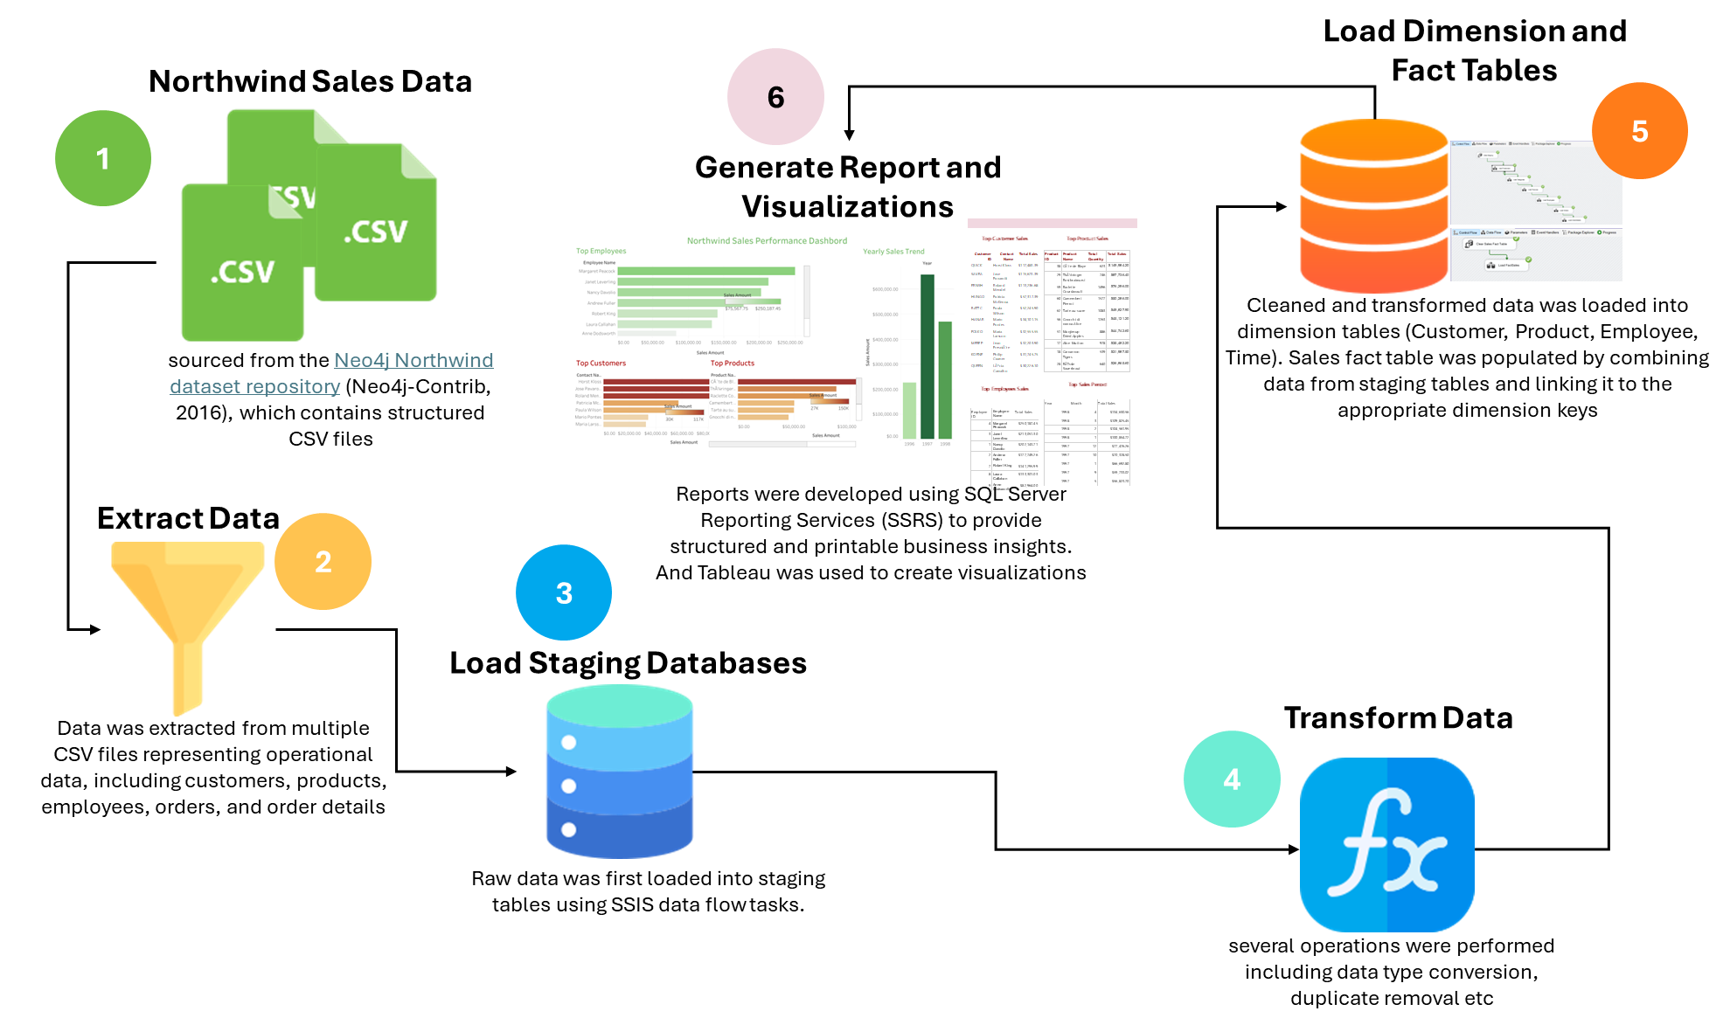
Figure 1: Data warehouse design workflow

2. SCHEMA

The data warehouse is designed using a star schema dimensional model. The star schema organizes the data into a central fact table connected to multiple dimension tables, allowing for efficient querying and analysis. For the purpose of this project, the schema used sales transaction as the fact table. Each record in the fact table represents a the sale of a specific product.

2.1 FacT TABLE
The central fact table in the data warehouse is the Sales table. This table captures transactional data representing individual sales of products. Each record in the Sales fact table corresponds to a single sales transaction and contains measurable business metrics. Table 1 includes the following key attributes, and Figure 2 shows the star schema design for the data warehouse. This structure supports efficient querying and enables multidimensional analysis across different perspectives such as customer, product, time, and employee.
Table 1: Key attributes and their description
Keys | Description
SalesID | unique identifier for each transaction
CustomerID | foreign key linking to the Customer dimension
ProductID | foreign key linking to the Product dimension
EmployeeID | foreign key linking to the Employee dimension
TimeID | foreign key linking to the Time dimension
SalesAmount | total revenue generated from the transaction
Quantity | number of units sold
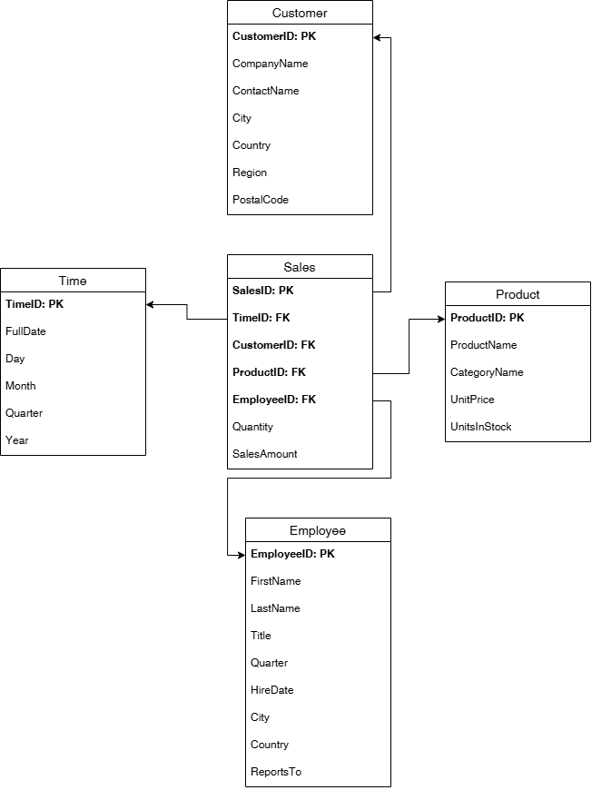
Figure 2: Star schema design for data warehouse

3. ETL
The Extract, Transform, Load (ETL) process was implemented using SQL Server Integration Services (SSIS) to populate the data warehouse from CSV source files.

3.1. Extract Phase
Data was extracted from multiple CSV files representing operational data, including customers, products, employees, orders, and order details. These files were imported into staging tables within the database.

3.2. TransformATION
During transformation, several operations were performed including:
- Data type conversions (e.g., resolving Unicode vs non-Unicode conflicts)
- Removal of duplicates caused by multiple staging loads
- Data cleaning to ensure consistency across keys and attributes
Some data happened during the load phase to address different challenges surrounding mismatch in database and csv data types.

3.3. Load Phase
The loading process was divided into three main stages:
- Load Staging Tables
Raw data was first loaded into staging tables using SSIS data flow tasks.
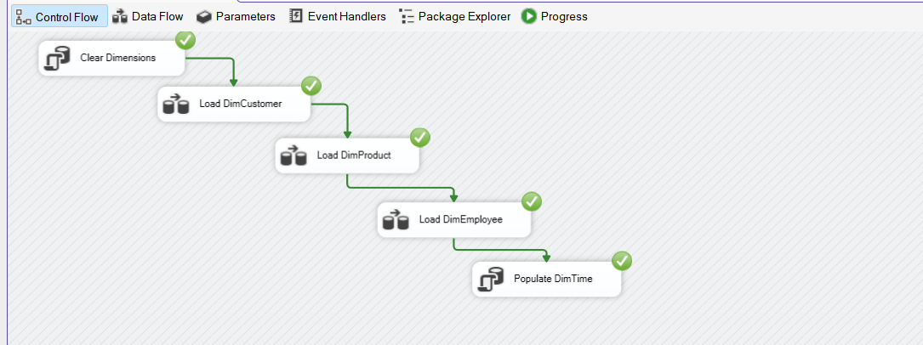
Figure 3: Raw data loaded into staging tables
- Load Dimension Tables
Cleaned and transformed data was loaded into dimension tables (Customer, Product, Employee, Time). Referential integrity was maintained using primary and foreign keys.
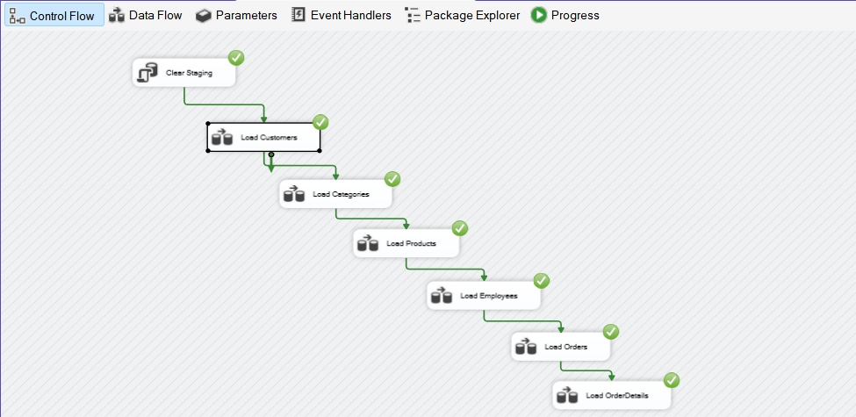
Figure 4: Cleaned and transformed data loaded into dimension tables
- Load Fact Table
The Sales fact table was populated by combining data from staging tables and linking it to the appropriate dimension keys.
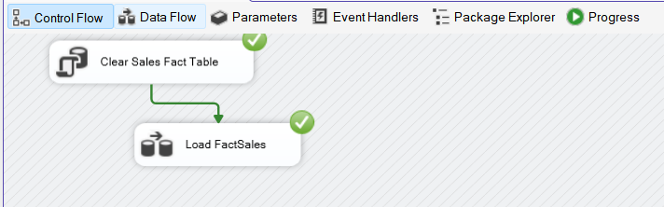
Figure 5: Loaded Sales Fact Tables
Multiple SSIS packages were created:
- Load Staging Package
- Load Dimensions Package
- Load Fact Sales Package
A master package was used to execute all processes sequentially.
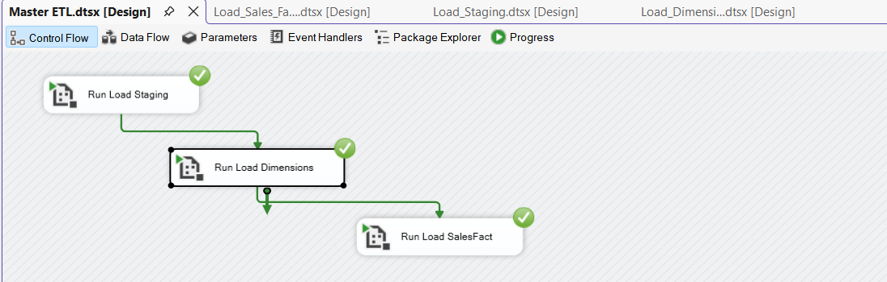
Figure 6: Master package to carry out the entire tasks.

4. VISUALIZATIONS AND REPORTS
The loaded dimension and sales fact tables were used to generate visualizations and reports in Tableau and SSRS respectively.

4.1. Visualizations
The visualizations were developed using Tableau to support the identified business requirements. The following four (4) visualizations were created (see Figure 7):
- Top Customers: A bar chart showing the highest revenue-generating customers.
- Top Products: A ranked visualization of products generating the most sales.
- Yearly Sales: A bar chart displaying total sales across 3 years.
- Top Employee: A comparative bar chart showing total sales per employee.
These visualizations were integrated into a Tableau dashboard, providing an interactive interface for exploring business insights.
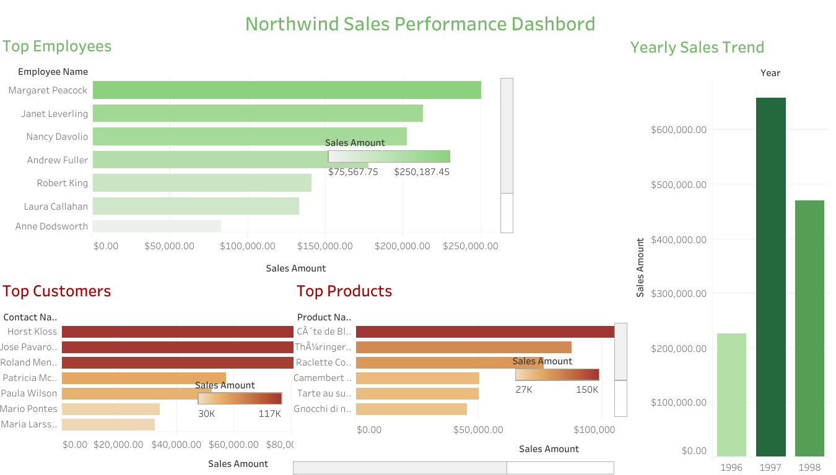
Figure 7: Tableau Dashboard showing key visualizations

4.2. Reports
Reports were developed using SQL Server Reporting Services (SSRS) to provide structured business insights.
The following reports were created:
- Top Customers by Sales: shows the highest revenue-generating customers.
- Top Products Sales: shows a ranking of products generating the most sales.
- Top Sales Period: A table peak sale periods by month and year.
- Top Employee Sales: A comparison table showing total sales per employee.
Table 2 – 5 show the reports generated using SSRS and exported.
  Table 2: Top Customer Sales
  Table 3: Top Product Sales
  Customer ID | Contact Name | Total Sales
  QUICK | Horst Kloss | $117,483.39
  SAVEA | Jose Pavarotti | $115,673.39
  ERNSH | Roland Mendel | $113,236.68
  HUNGO | Patricia McKenna | $57,317.39
  RATTC | Paula Wilson | $52,245.90
  HANAR | Mario Pontes | $34,101.15
  FOLKO | Maria Larsson | $32,555.55
  MEREP | Jean FresniÃ¨re | $32,203.90
  KOENE | Philip Cramer | $31,745.75
  QUEEN | LÃºcia Carvalho | $30,226.10
  Product ID | Product Name | Total Quantity | Total Sales
  38 | CÃ´te de Blaye | 623 | $149,984.20
  29 | ThÃ¼ringer Rostbratwurst | 746 | $87,736.40
  59 | Raclette Courdavault | 1496 | $76,296.00
  60 | Camembert Pierrot | 1577 | $50,286.00
  62 | Tarte au sucre | 1083 | $49,827.90
  56 | Gnocchi di nonna Alice | 1263 | $45,121.20
  51 | Manjimup Dried Apples | 886 | $44,742.60
  17 | Alice Mutton | 978 | $35,482.20
  18 | Carnarvon Tigers | 539 | $31,987.50
  28 | RÃ¶ssle Sauerkraut | 640 | $26,865.60
  Table 5: Top Sales Period
Table 4: Top Employees Sales

Year | Month | Total Sales
1998 | 4 | $134,630.56
1998 | 3 | $109,825.45
1998 | 2 | $104,561.95
1998 | 1 | $100,854.72
1997 | 12 | $77,476.26
1997 | 10 | $70,328.50
1997 | 1 | $66,692.80
1997 | 9 | $59,733.02
1997 | 5 | $56,823.70
1997 | 4 | $55,699.39

Employee ID | Employee Name | Total Sales
4 | Margaret Peacock | $250,187.45
3 | Janet Leverling | $213,051.30
1 | Nancy Davolio | $202,143.71
2 | Andrew Fuller | $177,749.26
7 | Robert King | $141,295.99
8 | Laura Callahan | $133,301.03
9 | Anne Dodsworth | $82,964.00
6 | Michael Suyama | $78,198.10
5 | Steven Buchanan | $75,567.75

5. Graph Databases
In addition to the relational data warehouse, a graph database was implemented using Neo4j to explore relationships within the data. The graph model represents data as nodes and relationships:
- Nodes: Customer, Sales, Product, Employee, Time
- Relationships:
- Sales PURCHASED_BY Customer
- Sales INCLUDES Product
- Sales HANDLED_BY Employee
- Sales OCCURRED_ON Time
Graph databases provide a more natural way to model and query interconnected data compared to traditional relational systems. Figure 8 provides a visual representation of the nodes and relationships between them.
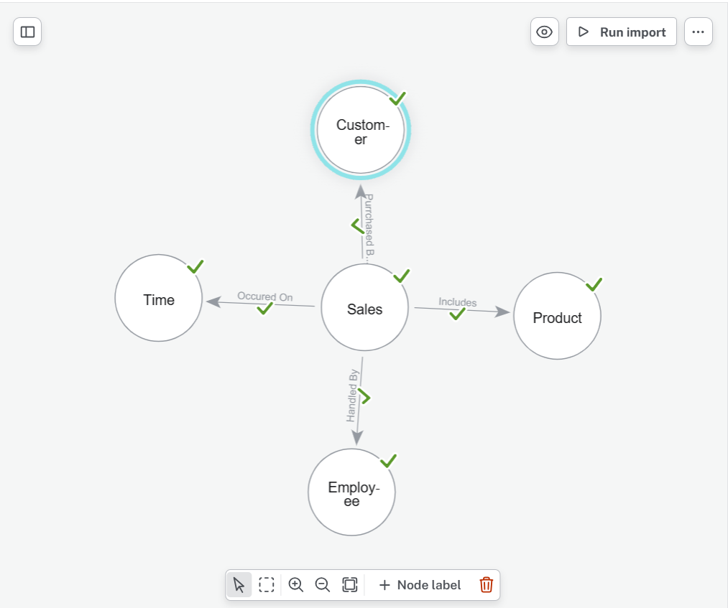
Figure 8: Neo4j UI showing validated nodes and relationships

5.1. COMPARISON to realtional databases
Relational and graph databases differ fundamentally in their structural paradigms and data representation techniques. Relational databases rely on structured tables and foreign keys to organize data, while graph databases like Neo4j utilize nodes and relationships to model complex interconnections. In this comparison, query execution times were excluded as a primary metric due to the high variance in results, which prevented a consistent performance baseline. However, a significant distinction was observed in the query languages; Cypher Query Language (CQL) proved to be more intuitive and concise than SQL. Queries that necessitate complex, multi-line joins in a relational environment are often reduced to just a few lines in CQL, simplifying the developer's workflow when navigating interconnected datasets (See Appendix A and B for visualization and code respectively).
The most striking difference between the two systems lies in how they visualize and return results. In this study, queries Q1 through Q6 returned standard tabular data in both SQL Server and Neo4j, showing little functional difference for basic data retrieval. However, query Q7, which was designed to trace a path from customers to products via sales, highlighted a major divergence in capabilities. While SQL Server could only provide a flat list of data, Neo4j represented the output as a visual graph, explicitly mapping the relationships between entities. This ability to capture and display the visual flow of data underscores the inherent advantage of graph databases for pathfinding and relational analysis where SQL Server fails to provide a meaningful visual context.
Table 6: Summary of differences between SQL and Neo4j
Feature | Relational (SQL) | Graph (Neo4j)
Model | Tables / Rows / Columns | Nodes / Relationships / Properties
Connectivity | Joins via Foreign Keys | Direct Pointers (Edges)
Syntax | Structured Query Language (SQL) | Cypher Query Language (CQL)
Best For | Structured data & transactional integrity | Complex relationship mapping & pathfinding

6. Conclusions

This project successfully developed a proof-of-concept data warehouse using a dimensional model to support business intelligence for sales analysis. The ETL process ensured accurate and consistent data integration from multiple sources, while SSRS reports and Tableau visualizations provided meaningful insights into customer behavior, product performance, employee productivity, and sales trends.
Additionally, the implementation of a graph database demonstrated the advantages of using graph-based models for analyzing relationships within data. The comparison between relational and graph databases highlighted their respective strengths, showing that each approach serves different analytical needs.

7. Bibliography
- Bonifati, A. et al. (2001) “Designing data marts for data warehouses,” ACM Transactions on Software Engineering and Methodology, 10(4), pp. 452–483. Available at: https://doi.org/10.1145/384189.384190;CTYPE:STRING:JOURNAL.
- Brown, W., Wilson, G. and Johnson, O. (2024) “Understanding the Role of Big Data Analytics in Enhancing Customer Experience.” Available at: https://doi.org/10.20944/preprints202408.0365.v1.
- Gade, K.R. (2021) “Data-Driven Decision Making in a Complex World,” Journal of Computational Innovation, 1(1). Available at: https://researchworkx.com/index.php/jci/article/view/2 (Accessed: April 9, 2026).
- GitHub - neo4j-contrib/northwind-neo4j · GitHub (no date). Available at: https://github.com/neo4j-contrib/northwind-neo4j (Accessed: April 10, 2026).
- HasanEmon (2025) “Big Data-Driven Business Process Optimization: Enhancing Decision-Making Through Predictive Analytics.” Available at: https://doi.org/10.36227/TECHRXIV.175987736.61988942/V1.
- Nookala Jp, G. (2023) “Real-Time Data Integration in Traditional Data Warehouses: A Comparative Analysis,” Journal of Computational Innovation, 3(1). Available at: https://researchworkx.com/index.php/jci/article/view/15 (Accessed: April 10, 2026).

Appendix A – VISUALIZATIONS Code For Q7
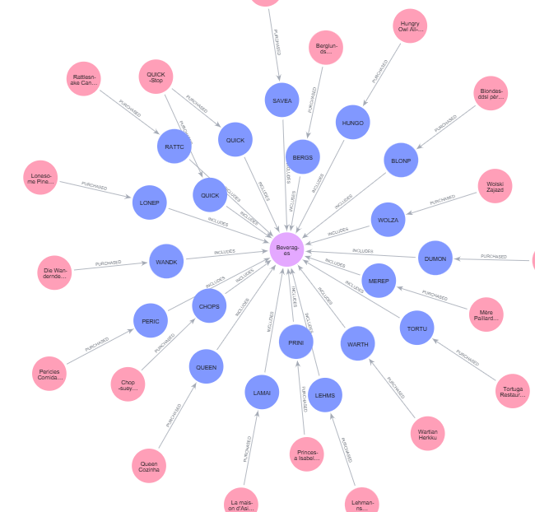ORDER BY Customers.CustomerID;

Appendix B – COMPARISON OF Neo 4J code AND SQL
Query | Description | CQL | SQL
Q1 | Top Customers by Sales | MATCH (s:Sales)-[:PURCHASED_BY]->(c:Customer)  RETURN c.CustomerID, c.ContactName, SUM(s.SalesAmount) AS TotalSales  ORDER BY TotalSales DESC LIMIT 10; | SELECT TOP 10  c.CustomerID,  c.ContactName,  SUM(s.SalesAmount) AS TotalSales  FROM dbo.Sales s  JOIN dbo.Customer c  ON s.CustomerID = c.CustomerID  GROUP BY c.CustomerID, c.ContactName  ORDER BY TotalSales DESC;
Q2 | Top Products by Revenue | MATCH (s:Sales)-[:INCLUDES]->(p:Product)  RETURN  p.ProductName,  SUM(s.SalesAmount) AS TotalSales  ORDER BY TotalSales DESC  LIMIT 10; | SELECT TOP 10  p.ProductName,  SUM(s.SalesAmount) AS TotalSales  FROM dbo.Sales s  JOIN dbo.Product p  ON s.ProductID = p.ProductID  GROUP BY p.ProductName  ORDER BY TotalSales DESC;
Q3 | Employee Performance | MATCH (s:Sales)-[:HANDLED_BY]->(e:Employee)  RETURN  e.FirstName + ' ' + e.LastName AS EmployeeName,  SUM(s.SalesAmount) AS TotalSales  ORDER BY TotalSales DESC; | SELECT  e.FirstName + ' ' + e.LastName AS EmployeeName,  SUM(s.SalesAmount) AS TotalSales  FROM dbo.Sales s  JOIN dbo.Employee e  ON s.EmployeeID = e.EmployeeID  GROUP BY e.FirstName, e.LastName  ORDER BY TotalSales DESC;
Q4 | Sales Over Time | MATCH (s:Sales)-[:OCCURRED_ON]->(t:Time)  RETURN  t.Year,  SUM(s.SalesAmount) AS TotalSales  ORDER BY t.Year; | SELECT  t.Year,  SUM(s.SalesAmount) AS TotalSales  FROM dbo.Sales s  JOIN dbo.Time t  ON s.TimeID = t.TimeID  GROUP BY t.Year  ORDER BY t.Year;
Q5 | Customers with Similar Purchases | MATCH (c1:Customer)-[:PURCHASED]->(s1:Sales)-[:INCLUDES]->(p:Product)  MATCH (c2:Customer)-[:PURCHASED]->(s2:Sales)-[:INCLUDES]->(p)  WHERE c1 < c2  RETURN  c1.CustomerID,  c2.CustomerID,  p.ProductName,  COUNT(*) AS TimesBoughtSameProduct  ORDER BY TimesBoughtSameProduct DESC; | SELECT  c1.CustomerID,  c2.CustomerID,  p.ProductName,  COUNT(*) AS TimesBoughtSameProduct  FROM dbo.Sales s1  JOIN dbo.Sales s2  ON s1.ProductID = s2.ProductID  JOIN dbo.Customer c1  ON s1.CustomerID = c1.CustomerID  JOIN dbo.Customer c2  ON s2.CustomerID = c2.CustomerID  JOIN dbo.Product p  ON s1.ProductID = p.ProductID  WHERE c1.CustomerID < c2.CustomerID  GROUP BY c1.CustomerID, c2.CustomerID, p.ProductName  ORDER BY TimesBoughtSameProduct DESC;
Q6 | Products Bought Together | MATCH (s:Sales)-[:INCLUDES]->(p1:Product)  MATCH (s)-[:INCLUDES]->(p2:Product)  WHERE p1.ProductID < p2.ProductID  RETURN  p1.ProductName,  p2.ProductName,  COUNT(*) AS TimesBoughtTogether  ORDER BY TimesBoughtTogether DESC; | SELECT  p1.ProductName AS Product1,  p2.ProductName AS Product2,  COUNT(*) AS TimesBoughtTogether  FROM dbo.Sales s1  JOIN dbo.Sales s2  ON s1.SalesID = s2.SalesID  AND s1.ProductID < s2.ProductID  JOIN dbo.Product p1  ON s1.ProductID = p1.ProductID  JOIN dbo.Product p2  ON s2.ProductID = p2.ProductID  GROUP BY  p1.ProductName,  p2.ProductName  ORDER BY TimesBoughtTogether DESC;
Q7 | Customer to Product Path | MATCH path =  (c:Customer)-[:PURCHASED]->(s:Sales)-[:INCLUDES]->(p:Product)  RETURN path  LIMIT 20; | SELECT TOP 20  c.CustomerID,  c.ContactName,  s.SalesID,  p.ProductID,  p.ProductName  FROM dbo.Customer c  JOIN dbo.Sales s  ON c.CustomerID = s.CustomerID  JOIN dbo.Product p  ON s.ProductID = p.ProductID;

